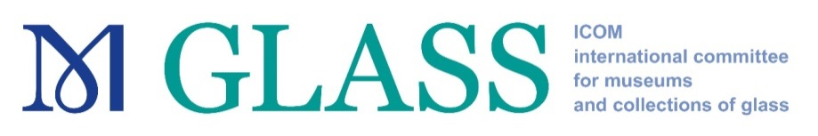

ICOM Glass Annual Meeting 2021

‘The End of Glass Production – The Beginning of Museums? Deindustrialization and museums in glass production areas’

Southern Germany, 2-9 May 2021

GRANTS for Young Members’ attendance

GLASS is awarding two different grants for the attendance of the ICOM GLASS Meeting 2021 in Southern Germany. They are available to members who are 40 years of age or under on 31 December 2020.

1. Young ICOM members’ travel grant programme
Starting from 2018, the award of Travel Grants for Young ICOM Members to attend ICOM International Committee Annual Meetings is managed directly by each one of the thirty ICOM International Committees. For 2021 ICOM is providing up to € 1200 for transport, accommodation, and conference fee for a young professional.
2. ICOM Glass Scholarships 2021
In addition, GLASS is offering two scholarships worth up to € 700 each. The scholarships can be used for transport, accommodation and conference fee.

All grants are provided on a reimbursement basis. The grantees are required to present an account of expenditure of the scholarship, providing receipts. The committee will reimburse expenses only on submitted receipts after the meeting.
All applicants should be:
- 40 years of age or under on 31 December 2020.
- Up to date with their membership dues for 2018, 2019 and 2020.

Priority will be given to those applicants:

- who are individual members of GLASS IC;
- who reside in countries belonging to categories 2, 3 and 4 as defined in the ICOM membership grid (https://icom.museum/en/resources/documents/);

- who are full-time employees of a museum;
- who are under 35 years;
- who may obtain other sources of funding to enable their attendance at the meeting.
Young members who have received grants in the last three years (2017, 2018 and 2019) are invited to apply, however they will not be given priority for a grant in 2021.

All applications must include:
    - the completed and signed attached application form;
    - a short statement of the applicant’s motivation for attending the annual meeting and the benefits which he/she expects to derive from it;
- the applicant’s curriculum vitae indicating training, work experience, publications, as well as current work responsibilities within his/her institution (maximum one page);
- a copy of a valid travel document (passport, identity card).

Applications can be made by email until 30th November 2020 to the Secretary of the ICOM GLASS Committee, Maria Luisa Martinez, mava@ayto-alcorcon.es .
The nominees will be informed by 15th December 2020.
The grantees will be required to attend all the activities organized by the Glass Annual Meeting 2021.

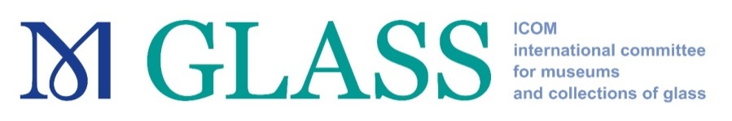

APPLICATION FORM

Applicant Details
Surname(s)
First name(s)
Date of birth
(Please include a copy of your passport)
Individual ICOM Membership number
ICOM member since
Member of GLASS
since
Institution
Position in your Institution
Professional Address
City Postal code Country
Telephone number
E-mail
Additional Information
Are you an active member of other ICOM National or International Committees? (Please specify) Please note that you cannot attend more than one IC meeting in 2018 by means of this travel grant.
budget plan for the expenses

Do you have any additional funding possibilities? (Please specify)

Have you benefitted from ICOM Travel Grants in previous years?
If YES, please specify the type of meeting, the venue and country, as well as the year. (for example: ICOM General Conference, Rio de Janeiro, Brazil, 2013)

I herewith declare:
- that I am 40 years or younger (as of 31 December 2020) and eligible to apply according to the Criteria;

- that I am available to FULLY attend the aforementioned ICOM GLASS International Committee Meeting.

Date | Applicant’s Signature

This application form shall not be considered if all fields are not filled in

