


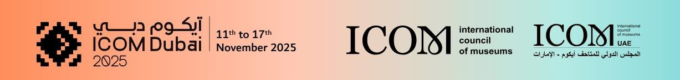

November 12 13:00 – 14h30
Joint meeting: GLASS and DESIGN (former ICDAD)-session A10
Adornments and Identity
Dubai World Trade Centre, Dubai, UAE
Sheikh Rashid Hall B C-7
Keynote Address
- Changing Face of a Glass Object, a Narrative of Research Journey in Times and Places”
Salehvand NAVID (Director of Glass and Ceramic Museum of Iran, Tehran, Iran) and Moghayer Zohreh MOHAMMADIAN (Senior Curator of Glass and Ceramic Museum of Iran in Tehran, Iran)
Presentations
- The Wreath of the Bride from Oaș Country, Romania and the Art of Identity Reconstruction Mihaela GRIGOREAN (Satu Mare County Museum, Satu Mare, Romania)
- Adornment and Identity: Case of Study Based on the Museu Nacional D’Art Collections Mariangels FONDEVILA (Curator of Modern Art, Museu Nacional d'Art de Catalunya, Barcelona, Spain)
- Adorning the Invisible: Herta Ottolenghi Wedekind’s Textile Language of Symbolism and Meaning” Diletta HABERL (PhD student in Art History at the Department of Humanities, University of L’Aquila, Italy)
- Adornment and Identity: Material Culture in Indian Sanskrit Literature and Museum
- Collections” Sakshi KUKRETI (Museum Consultant and Independent Curator, Delhi, India)
Moderation:
Denise HAGSTRÖMER (DESIGN Board Member and Senior Curator of Design at the National Museum of Art, Architecture and Design, Oslo, Norway)
Anika REINEKE (DESIGN Board Member and Curator of Textiles, Decorative and Applied Arts and the Henry van de Velde Museum, Kunstsammlungen Chemnitz, Germany)
Melissa RINNE (DESIGN Chair and Senior Specialist, Kyoto National Museum, Japan)
November 12 14:45 – 16h15
Glass session B- Future Museums of Glass and rapidly Changing communities
Dubai World Trade Centre, Dubai, UAE
Dubai A&B B-5
- Experimenting the glassmaker’s craft through digitization Anne-Laure CARRÉ (Curator
- Rediscovered- a virtually unknown glass collection Eva-Maria GÜNTHER (Glass Curator Reiss-Engelhorn-Museen Mannheim, Germany)
Moderation:
Eva-Maria Günther, IC GLASS treasurer

November 13 14:30-16:00
Glass session C - Updates on glass –
Dubai World Trade Centre, Dubai, UAE
Al Ain K C-10
- Exhibition at Corning Museum of Glass, Brilliant Color, and upcoming glass events at the institution. Amy MC HUGH, Senior Curator at the Corning Museum of Glass, USA)
- Le Stanze del Vetro: Activities and Impact on the City of Venice. Manuela DIVARI (Le Stanze del Vetro, Vencie, Italy)
- Acquisition of the Glass Collection at the Museum of Prague 2000-2025 Milan HLAVES (Glass Curator at the Museum of Prague, CZ)
- The charm of Glass decorated Golden Jewelry from the Three Kings period of Korea Seongsil KIM (Glass Curator, Paris, France)
Moderation:
Anne-Laure Carré, IC GLASS secretary

Evening program:
ICOM IC Glass dinner and get together
November 14 9:00 – 12:00 Hotel Tour
Meeting point at the WTC
Excellence and international presence of Czech glassmaking Milan HLAVES (Glas curator at the Museum of Prague, CZ)

November 15 9:30 – 13:30 International Committee’s Day
Joint meeting: Icom Costume
Al Shindagha Museum
Departure from assembly point in World Trade center at 9:00
- 9h30-10h Welcome Introduction
- 10h- 10h30 Morning Coffee Break
- 10h30-12h30 Museum talks and tours (open to everyone)
- 12h30-13h30 Lunch Break at The Fish House

Afternoon program, only IC Glass menbers:
13h30Trip to Abu Dhabi, Louvre Abu Dhabi and Grand Mosque (Chandeliers, stained glass windows)

